# Software introduction

RockSL Rock and ore spectrum database operation software is a software used to manage mineral spectral data, the software can achieve domestic and foreign shared spectral data and related data import, quality inspection of spectral data, spectral data pre-classification, data retrieval, spectral data analysis and unknown spectrum matching.This software can help users to better achieve the management of large amounts of spectral data and mineral identification related applications.

At present, the shared data contained in RockSL database mainly come from JHU, JPL, USGS and Janice Bshop database, which contains 133 kinds of rock minerals and 25 mineral families. At present, there are 2550 spectral curves of rock minerals in the database.RockSL has carried out strict data cleaning operation on all shared spectral data, eliminating the unqualified rock and ore spectral data and only retaining the spectral curve with better quality.At the same time, the software also provides the original information of the original data for users to refer to.

# 2. User manual

## 1. User login

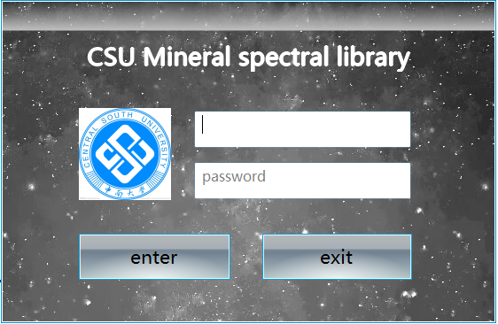

After the user enters the user name and password correctly, click Enter to enter the software. It should be noted that only the account registered in the software can log in, that is, the administrator needs to add personnel information before entering the software. Click Exit to exit the login interface and exit the software.

## 2. Software interface

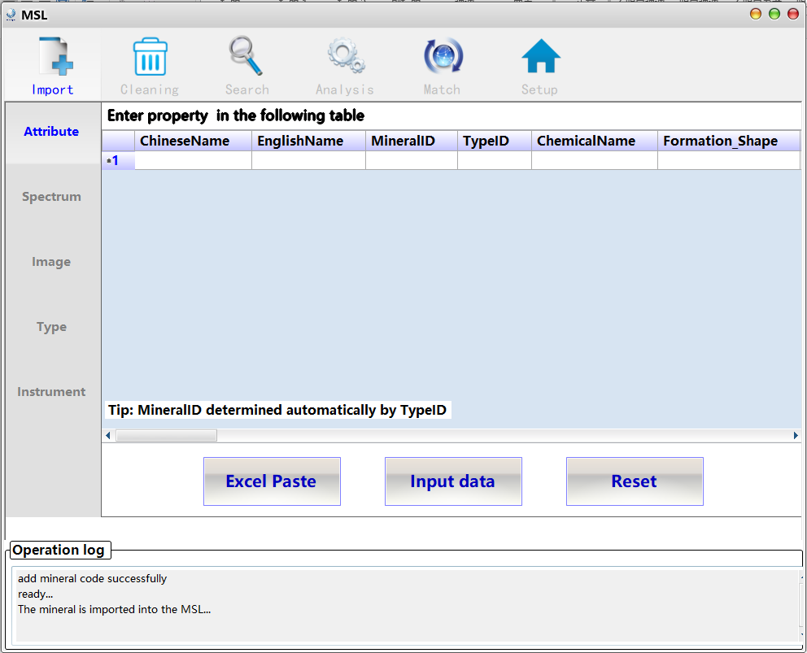

This interface is the data import interface of the software. The interface is designed in page switching mode. Click the corresponding label to enter different function pages.Note that only administrators can perform database operations, such as data import and data quality check. Common users cannot use these functions.As shown below.



The function pages on the interface mainly include data import, data cleaning, data retrieval, data analysis, data matching and other software functions. There are six main function pages in total.

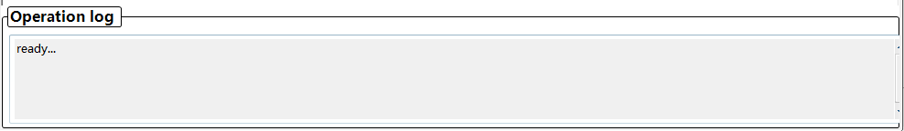

Software information is displayed at the bottom of the interface. During software operations, the corresponding operation information is displayed in this column to help users better use the software and understand the running status of the process.

## Data import

Click the Import TAB to open the "Data Import" interface.As shown below, this interface contains five types of data import, among which the most important is mineral spectrum data, which also includes mineral attribute data, vectorized coordinates of spectral curve images, mineral category information and information related to test instruments.



On the Attribute page, you can import mineral Attribute information.Click Excel Paste to open an external Excel file (the table header must be the same as that in the table header of the software) and copy and Paste the property information in the file to the software. Manual input in the table is avoided. If the amount of data to be imported is small, users can also manually enter data in the table.Note that the MineralID column does not require user input. The software assigns ids based on existing data in the database.After inputting all the information, click the button "Input Data" to realize the import of attribute data.The Reset button clears all data.

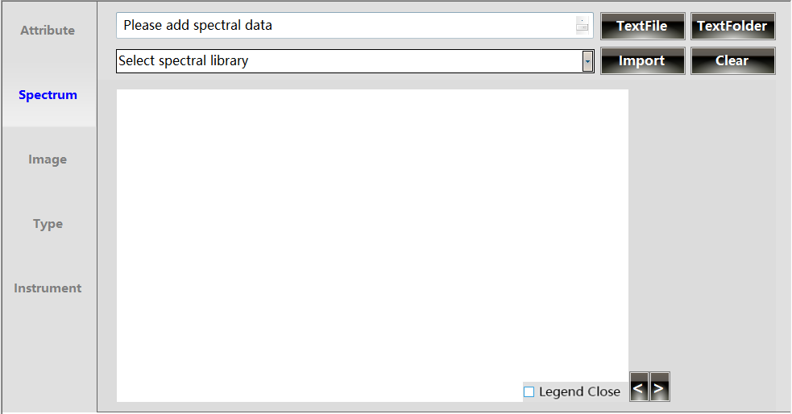

On the Spectrum page, you can import mineral spectral data.Users can select a single file or multiple files (in the form of folders) to import data, click "Open Folder" and "Open File" button to open the dialog box, and select spectral data files or folders.Select the database name to which the imported spectral data belongs from the drop-down box, click "Import" button to initially Import the data into the spectral database, and draw the spectral curves in turn to the following graphic window.If multiple spectral curves exist, you can also select the "Previous" (previous curve) button, "Next" (next curve) button and "Jump" (jump to any curve) button to display the imported spectral curve separately.Meanwhile, the corresponding parameter information of each spectral curve will be displayed in the information box on the right.Delete/ Clear clears the imported information and unchecked spectral data that has been imported to the spectral database.

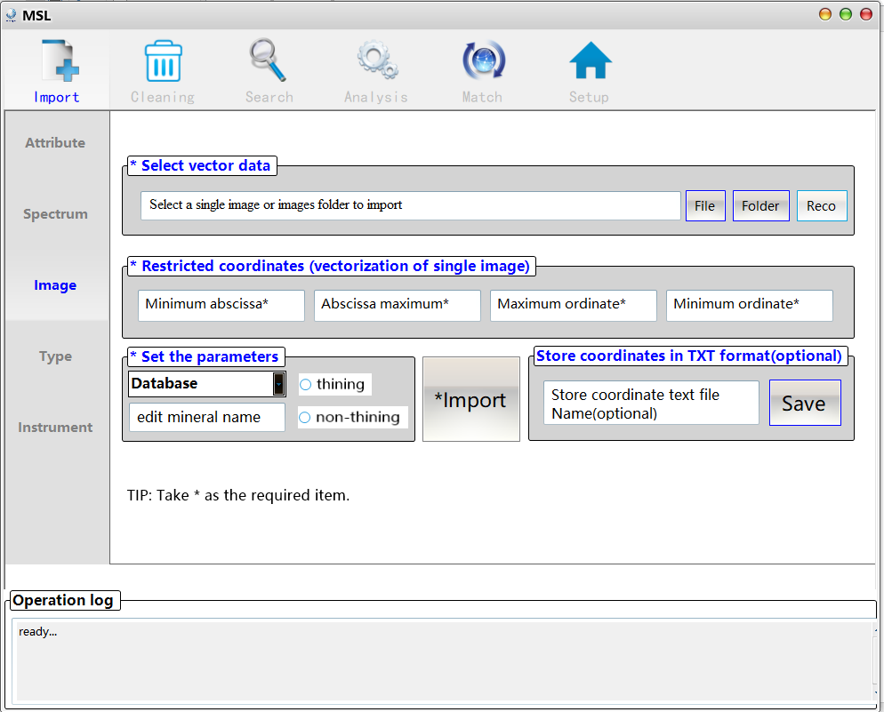

In the Image function page, the user can vectorize the spectral curve Image, extract the spectral curve coordinate according to the curve Image, and then import the spectral curve coordinate into the spectral library.This function interface can also realize the vectorization of single or multiple spectral curve images (import folder containing image files).Click "Image Folder" and "Image File" to open the corresponding dialog box and select the Image to be vectorized and imported into the spectrum library. If a single Image is imported (to ensure more accurate results and improve the detection rate), you need to manually input the maximum and minimum values of the x and Y coordinate axes of the curve.If there are multiple pictures, the software automatically identifies the maximum and minimum scale values by default.Confirm that the curve image file or folder is open, and set the corresponding parameters of the import: the database of the curve image, the name of the mineral that the image belongs to, and the selection of vectorization algorithm.Click the "Import" button to Import all vectorized coordinates.At the same time, users can also choose to Save vectorized coordinates in a text file, click the "Save" button to Save.

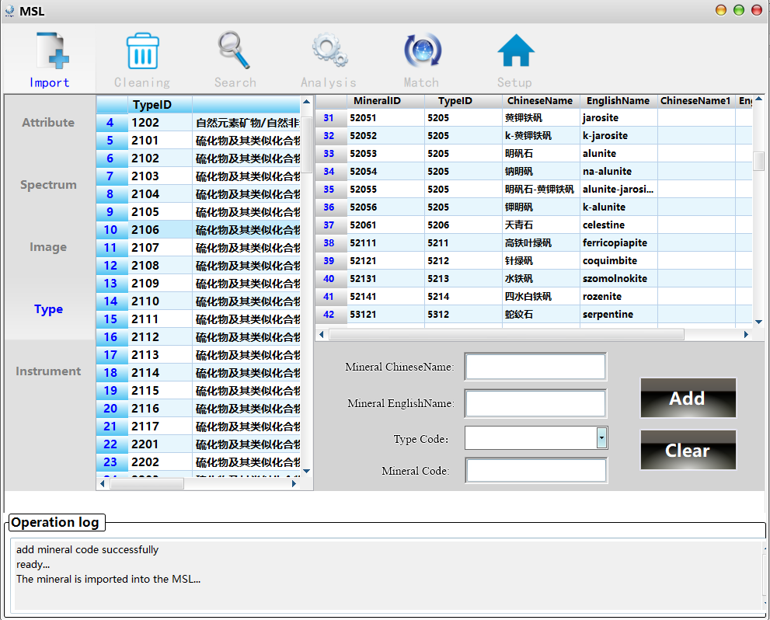

In the Type function page, it is mainly to help the administrator to manage the mineral Chinese-English comparison table of spectrum database.This table mainly helps to unify the shared data of multiple spectral libraries at home and abroad and realize the semantic unification of minerals at home and abroad.Enter the Chinese Mineral name in the Mineral ChineseName edit box, enter the corresponding English Mineral name in the Mineral EnglishName edit box, and select the corresponding Mineral category in the Type Code drop-down box. The software will automatically assign an ID to the Mineral.Click "Add" button to import the Chinese and English information of the mineral into the database, while "Clear" button is to Clear the input information.

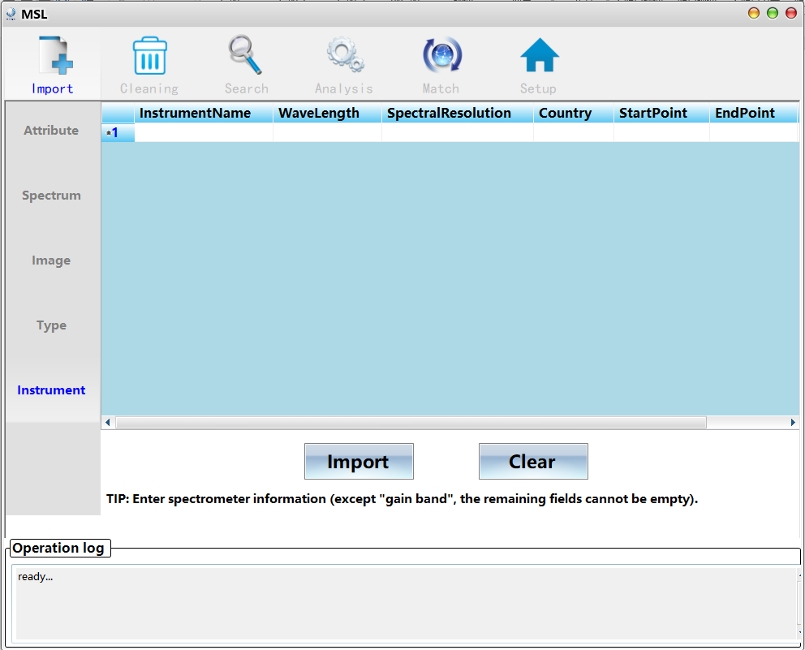

On the Instrument page, you can Import the spectrometer information to the spectrum library, manually add the Instrument information to the table, click Import to Import the entered information, and click Clear to Clear all information.

## 4. Data cleaning

All the spectral data imported into the mineral spectral database need to go through data quality inspection measures, so as to screen the qualified and representative spectral data and delete the unqualified or redundant data.This functional module mainly includes four functional interfaces: data preprocessing, data quality inspection, reprocessing and data classification.The following describes the four interfaces in detail.

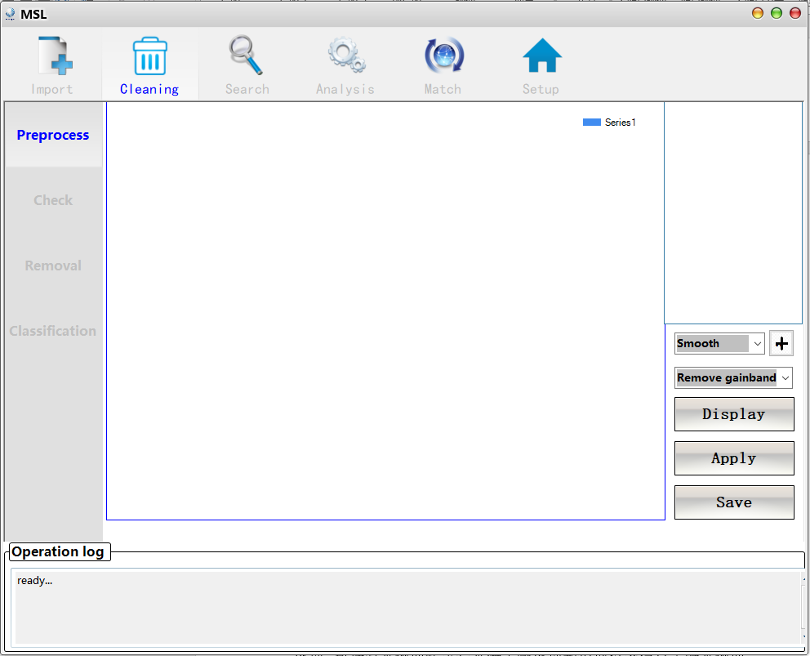

In the preProcess function page, users can preprocess the spectral curve data, including smooth de-noising of the spectral curve and removing the gain band of the spectral curve according to the instrument information.Click the "display" button to display the spectral curve without quality check in the blue picture box on the left and the file tree in the right frame, with each tree node corresponding to a mineral spectral data.Left-click a tree node to open a shortcut menuClick "smooth" to pull down the border to select the smooth filtering algorithm, click "remove gainband" to select whether to delete the gainband of the curve.Click "Apply" button to perform corresponding operations according to the selected pretreatment measures and draw curves.Click the "Save" button to save the corresponding results in the software memory.

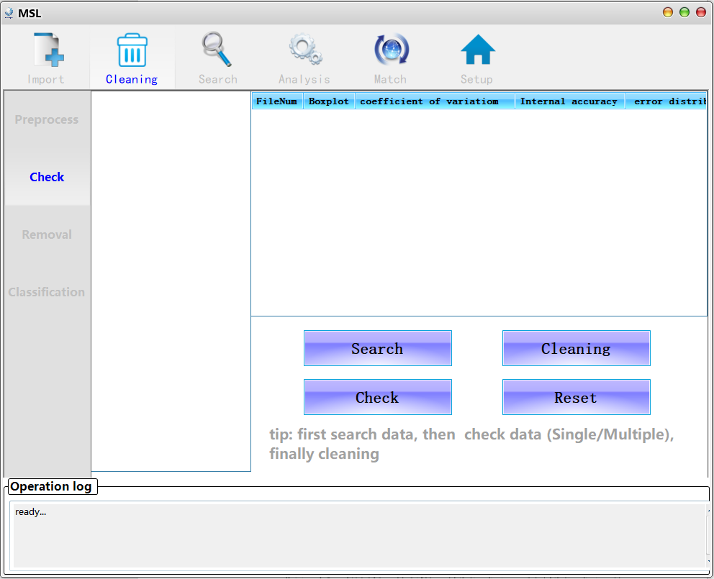

On the check page, users can check the quality of imported spectral curve data.Firstly, click the "Search" button to display the file tree of spectral data without data quality inspection in the left frame, and each tree node corresponds to one spectral data in turn.It should be noted that the quality inspection of vectorized coordinates of spectral curve pictures will be carried out in another quality inspection interface, whose interface and detailed operation are shown below.Every time you click the "Search" button, the software will first determine whether there are vector coordinates that need to be checked.Click the "Check" button to Check the quality of all spectral data, and display the quality Check results in the block diagram on the right.Click on the Cleaning button to automatically remove bad data.The Reset button clears the related information on the page.Note also that users can left-click the tree node to open the shortcut menu, you can browse the parameters of the spectral curve, draw the curve, and delete the curve.

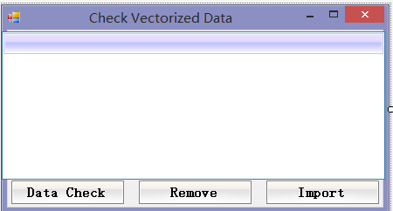

Click "Data Check" button to carry out quality Check and classification of vector Data, and display the results in the middle table.Click "Remove" button will automatically delete the data of poor quality.Click the "Import" button to Import spectral data into the database.

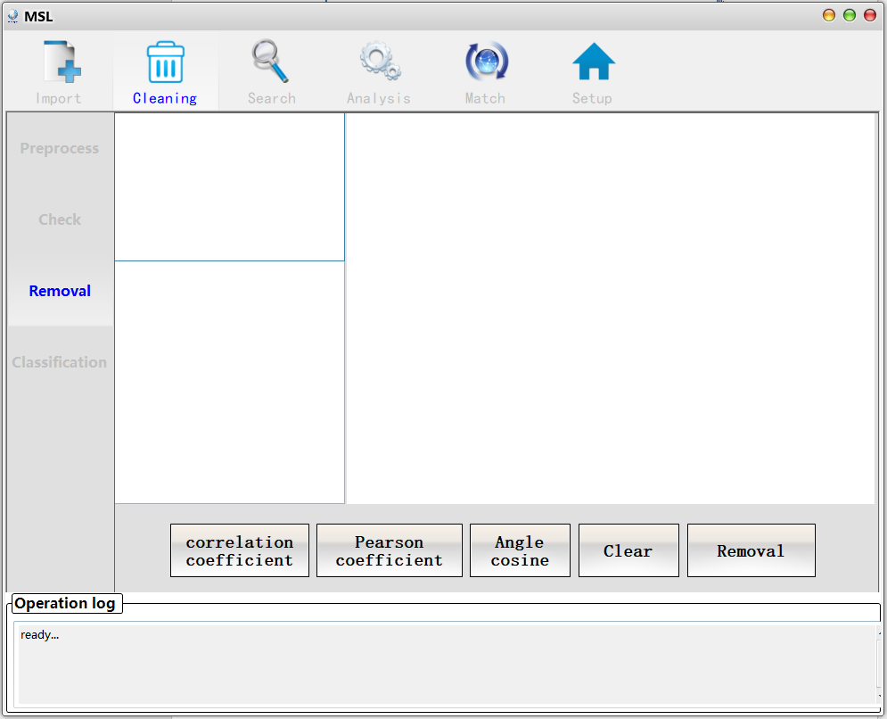

On the Removal page, users can click the correlation Coefficent, Pearson coefficient, and Cosine buttons, Software will be based on user selected button to use different methods to calculate the correlation between the existing spectral data (only for samples of the same instrument and the same minerals of spectral curve), the correlation coefficient matrix is displayed in the lower left corner in the block diagram, drawing will be all right border, if there is a group of related coefficient of high spectrum detected data, Software will select one of the representative curves into the database.Click the "Removal" button, and the software will remove the redundant spectral curves.Clicking the "Clear" button clears everything on the screen.

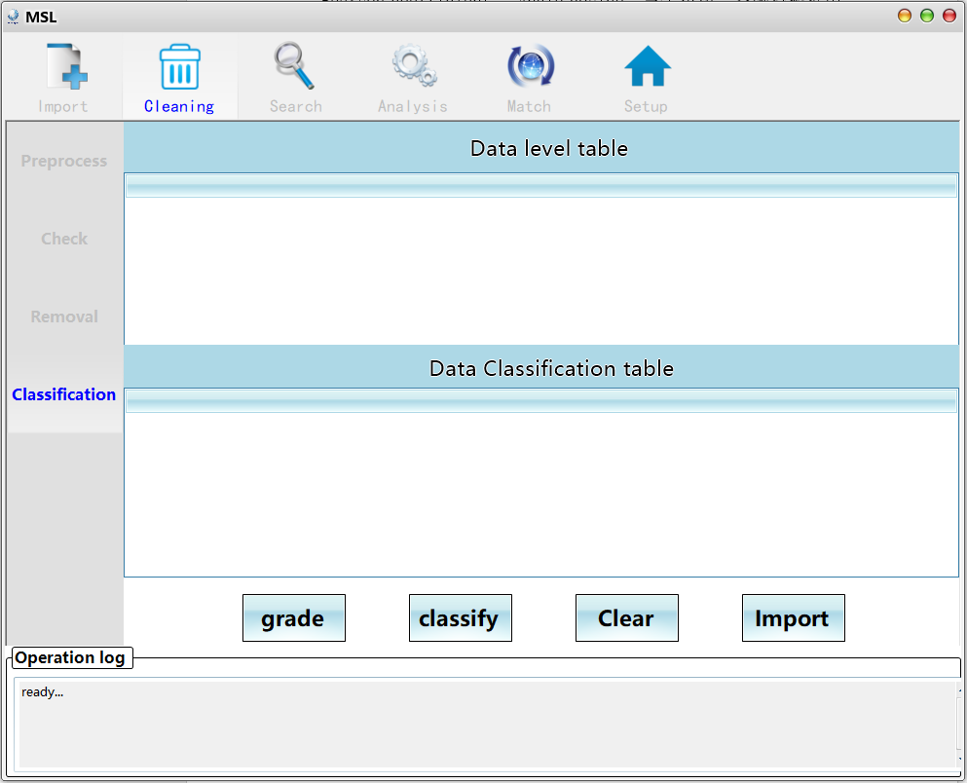

On the Classfication page, users can click the "Grade" button to grade the spectral data after quality inspection and reprocessing. The software mainly grades the data according to the parameter integrity of the spectral data.The result is displayed in the Data Level Table above.Users can click the "Classify" button to Classify the spectral Data after quality inspection and reprocessing. The software will calculate the combination of absorption positions of each spectral curve according to the algorithm designed by the author and display the results in the "Data Classfication table" in the following part.

## 5. Data retrieval

The functional interface of data retrieval mainly includes two parts: spectral data retrieval and attribute data retrieval.

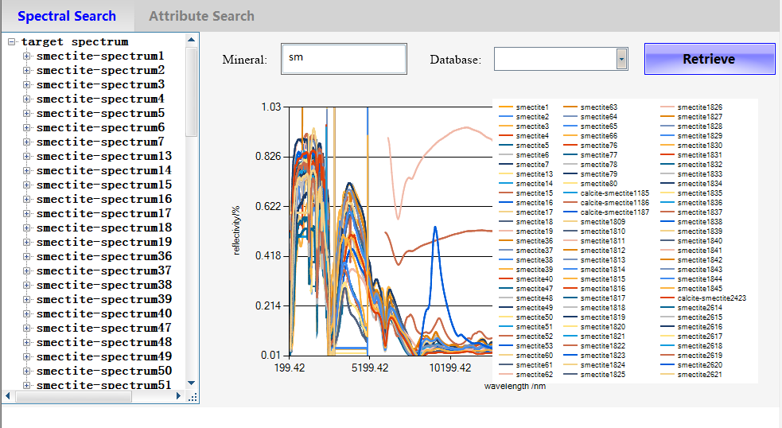

On the Spectral Search page, users enter the name of the mineral or database they want to search for.Software support Chinese and English search and fuzzy search (enter part of the mineral name information to search).Clicking the "Retrieve" button will display the spectral data of the target mineral retrieved from the spectral library in the left border, constructing a file tree with each spectral curve corresponding to a tree node.At the same time, the retrieved spectral curve is drawn to the block diagram on the right.

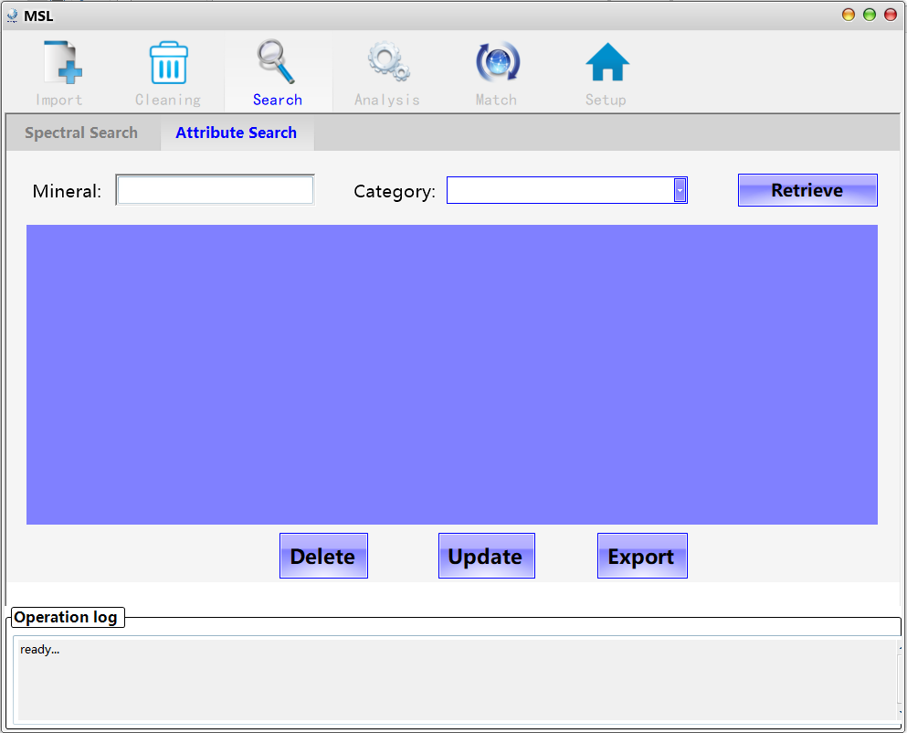

On the Attribute Search page, users enter the name of the mineral to be retrieved or the category to which the mineral belongs.Software support Chinese and English search and fuzzy search (enter part of the mineral name information to search).Clicking on the "Retrieve" button will display the target mineral attribute data from the spectral library in the table below, constructing a file tree with a tree node for each spectral curve.At the same time, the retrieved spectral curves are drawn to the left block diagram.

## 6. Data analysis

Data analysis interface is mainly used to analyze mineral spectral data, calculate characteristic value of spectral curve, calculate envelope of spectral curve and mark the position of absorption peak of curve

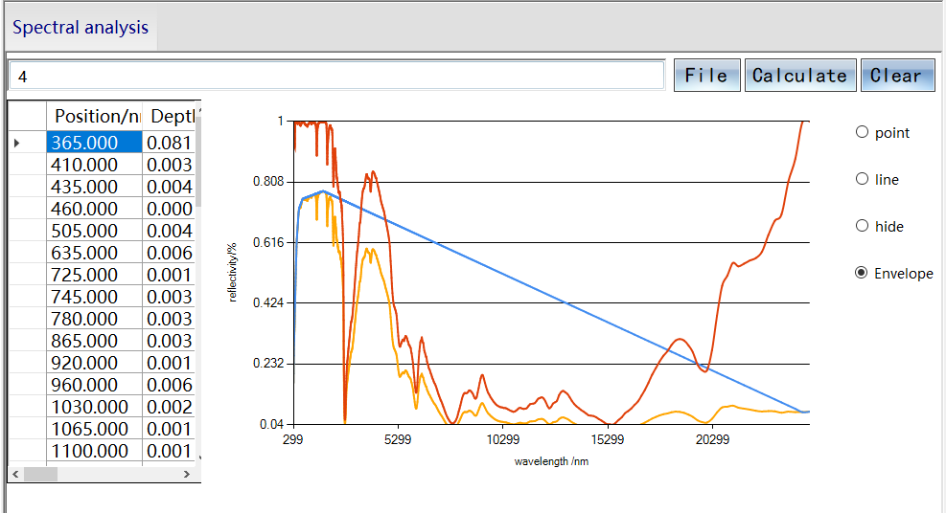

Click "File" button, in the File dialog box select the need analysis of the spectral curve data (text File), or from the spectrum retrieval interface retrieval to the target spectrum curve left key to jump to the data analysis of interface, click the "calculate" button, the software will calculate curve characteristic parameters and the results show that the blue box on the left, Including spectral absorption peak position, width, depth, etc., the analyzed curve is plotted in the figure box on the right.Click the point/line option to mark the position of curve absorption peak in the right picture box in the form of point/line.Click Hide to hide position annotation, click Envelop to draw envelop spectrum curve.

## 7. Spectral matching

Spectral matching interface is mainly based on the established mineral spectral library to realize spectral curve matching of unknown minerals to identify the mineral type.The detailed matching operations are as follows.

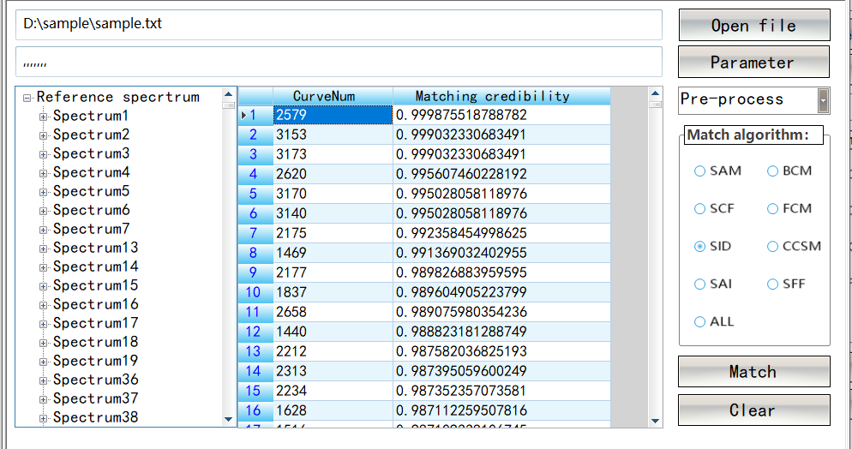

Firstly, click the "Open File" button, select the target spectrum (text file) for spectral matching, and then click the "Parameter" button to open the following form and limit the range of matching. For example, if you know the category or particle size of the spectral curve, you can fill in the information through the window below.If all information is unknown, it is recommended to use the "New Classifier" option (for the spectral classification method designed by the software based on curve characteristics, the software will first preclassify the data, and then compare it with the data of the same type in the spectral library).After the spectrum matching range is limited, select the "pre-Process" drop-down box to choose whether to perform envelope removal and quadratic differentiation of the target curve and reference curve before matching, and this operation can be ignored.In the algorithm option box on the right, select the algorithm for spectral matching. It should be noted that all option can be selected. This algorithm mainly integrates the results of all algorithms for average processing.Click the "Match" button for matching processing. Its left border is the file tree of all matched reference spectra, and each tree node represents a spectral data. The shortcut menu of the tree node is displayed by the left button, you can choose to draw the reference curve and the target curve in the same window to intuitively check whether the matching is accurate.Click the "Clear" button to clear all information on the screen.

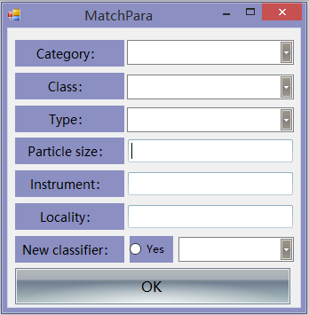

The matchPara interface is mainly used to limit the range of spectral matching.According to the prior information of unknown mineral spectrum, the corresponding category, particle size, instrument, place of origin and other information are set.If the information is unknown, select the new Classifier option and click Yes. At the same time, select the matching level: Class/class/family/mineral, where the matching speed is class > class > family > mineral, and the matching accuracy is class < class < family < mineral.

## 8. General software Settings

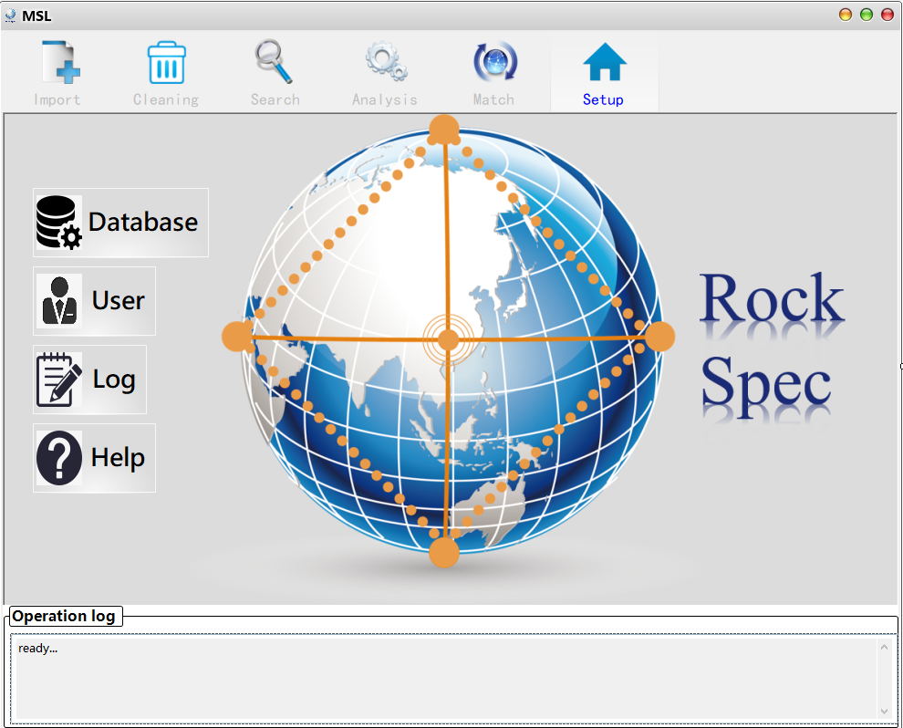

The main interface of general software Settings mainly realizes four functions: data backup and restoration, user setting, viewing operation logs and opening Help document.

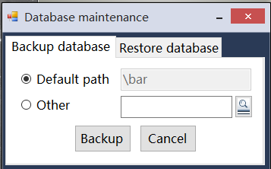

Database backup "Backup Database" function interface, this interface is mainly for the mineral spectrum database backup, users can choose the default address (software installation location) or self-set address.Click the "Backup" button to make a Backup and click the "Cancel" button to exit this window.

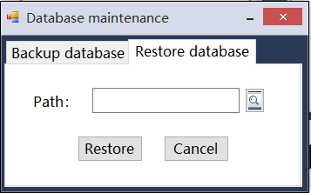

Restore database The "Restore Database" interface is used to Restore backup files. ClickButton to open the backup file and click "Restore" button to Restore the mineral spectrum library.

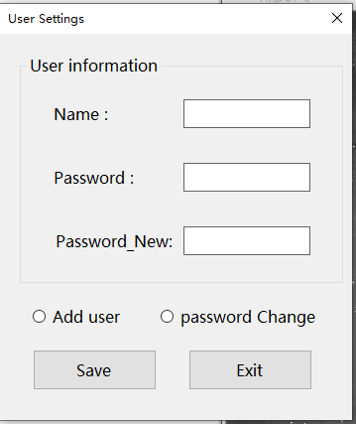

Set the user information screen, which is used to add new users and change passwords of old users.You must first select "Add User" (to Add a user) or "Password Change" (to Change the user password). If a new user is added, the field of the new password will be locked and cannot be operated.After filling in the necessary information, click "Save" button to Save the information set.

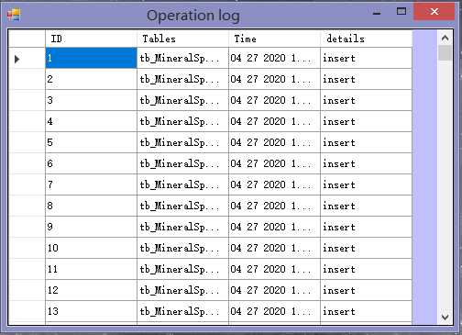

Click Openrate Log on the home screen to open the operation Log window. You can view the operation records of the database.